Manually Upload DICOM Files to Mobius

# Purpose

Usually, you should export DICOM files directly from the TPS (e.g., RayStation) to Mobius. However, you may need to export from the TPS to a file and then manually upload the file to Mobius.

# Steps

1. Export the DICOM files from the TPS. The target is a file, not Mobius. It is recommended to create a new folder specifically for the DICOM files.
2. Create a zip file of all the exported DICOM files.
3. In Mobius, click the gear icon in the top right corner.



1. Click the *DICOM Files* button.



1. Click *Choose File* and select the zip file.



1. When the name of the zip file appears, click *Upload DICOM File*.

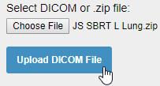

If the file was uploaded successfully, you should see a green banner at the top of the screen.



1. Optionally, browse the uploaded files.

Select the patient, modality, UID, and SOP. You should see a loading icon.

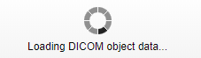

When loading is complete, you should see a list of fields.

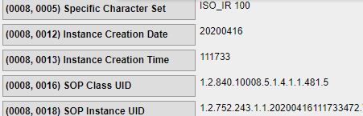

1. Continue in Mobius as if you had uploaded the DICOM data directly from the TPS. For example, if the uploaded DICOM data includes an RTPLAN, a plan check should start automatically.